Lions

Week | 2 | 3 | 4 | 5 | 6 | 7 | 8 | 9 | 10 | 11
Focus Sound | sh | ch | th | -ng | Revision | qu | ar | Days 1 | Days 2 | Revision
Spelling Words | wish  fish  shell  shop  shut  shape  shiver  shine | chips  lunch  chest  much  church  cheese  crunch  cheeky | this  with  that  thank  three  mother  thunder  thirsty | ring  sang  lung  thing  strong  springs  thing  reading | Revision  of all  words from this  term | quiz  queen  quit  quiet  quick  quack  quickly  quilt | arm  card  dart  hard  scarf  harp  hardest  started | Monday  Tuesday  Wednesday  Thursday  yesterday  year  week  month | Friday  Saturday  Sunday  today  weekend  tomorrow  term  holiday | Revision  of all  words from this  term
Magic Words | after  are  about  very  down | home  some  them  would  because | hour  house  going  off  could | over  their  around  who  found | Revision | night  knight  little  people  started | next  door  just  told  friend | where  which  school  before  once | police  boat  asked  morning  thought | Revision
Extension words | ashamed  shampoo | chocolate  chimney | thief  throat | gnome  envelope |  | question  quarter | farmyard  heart | anniversary  birthday | hours  leap year

Modern Victorian Script

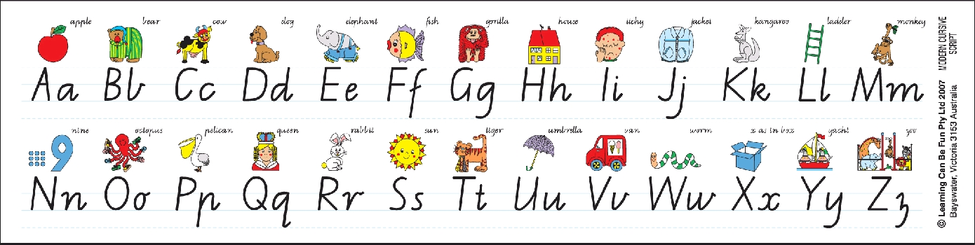
Year 1 Massey 2014

