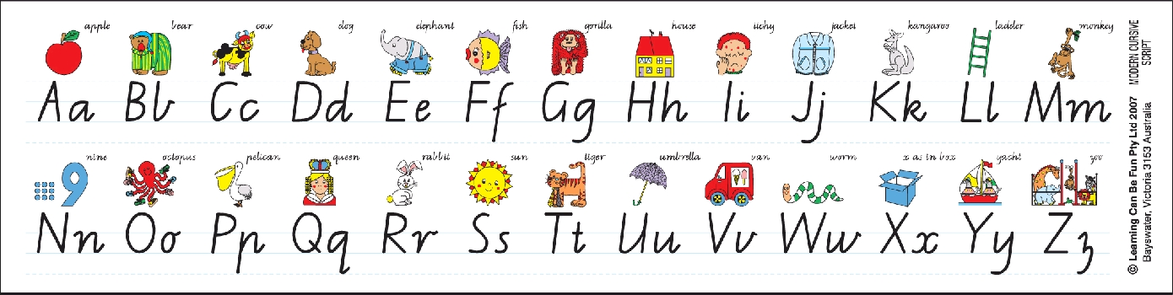

Year 1 Massey 2014

Year 1 Massey 2014