Tigers

Week | 2 | 3 | 4 | 5 | 6 | 7 | 8 | 9 | 10 | 11
Focus Sound | sh | ch | th | -ng | Revision | qu | ar | Days 1 | Days 2 | Revision
Spelling Words | wish  fish  shell  shop  shut | chips  lunch  chest  much  church | this  with  that  thank  three | ring  sang  lung  thing  strong | Revision  of all  words from this  term | quiz  queen  quit  quiet  quick | arm  card  dart  hard  scarf | Monday  Tuesday  Wednesday  Thursday  yesterday | Friday  Saturday  Sunday  today  weekend | Revision  of all  words from this  term
Magic Words | the  and  a  to  was | it  we  in  of  he | my  they  on  went  had | is  then  for  said  when | Revision | so  that  but  one  were | there  up  she  me  out | got  with  at  you  all | his  day  have  go  as | Revision

Modern Victorian Script

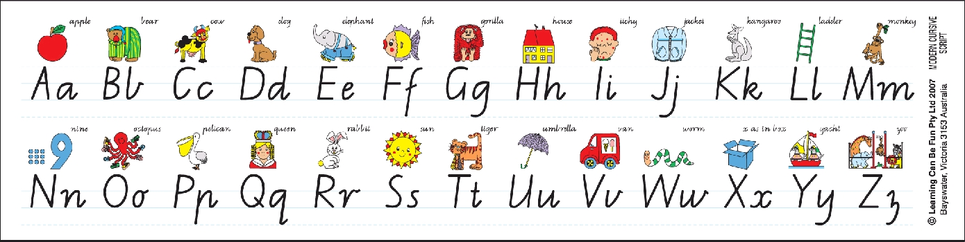
Year 1 Massey 2014

